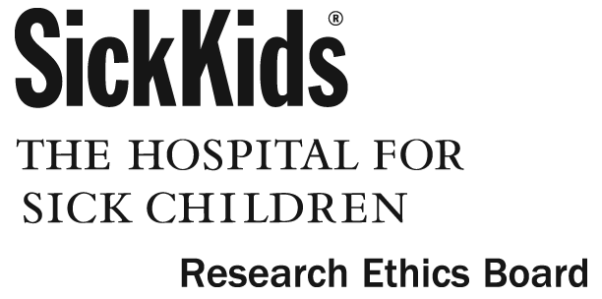

Research Consent Form

(Study participant)

Title of Research Project:
Prospective study of predictive factors in paediatric cholesteatoma.

Principle Investigator:
Dr A L James Principle Investigator 416 813 2191
Co-Investigators:
Dr S Cushing Co-investigator 416 813 2190
Dr B C Papsin Co-investigator 416 813 2190

Purpose of the Research:

When skin from the ear drum grows deep into the ear it can cause ear infections and damage the hearing. This is called cholesteatoma. Cholesteatoma can be treated with surgery but sometimes the hearing loss is permanent and sometimes cholesteatoma grows back again so more surgery can be needed. We would like to learn more about what makes cholesteatoma recur so we can learn how to treat it as effectively as possible.

Description of the Research:

In this study we will be analysing information about cholesteatoma and hearing levels before and after surgery. All the information we would like to analyse is already recorded in the hospital record of patients with cholesteatoma as part of standard care. We would like your permission to collect this information from your records. No extra tests or treatments are needed if you take part in this study.
If you agree, the information we would record would include:
- Your age, gender and previous medical history which may be related to cholesteatoma.
- Details about the extent of cholesteatoma in your ear, from pictures taken of your ear drum in clinic, from what is found during surgery and from any scans you may need as part of your treatment (eg CT scan or MRI scan).
- Your hearing level before and after surgery.
- Details about any specimens that are taken during surgery.
- If you have had any blood tests, including genetic testing, we would also like to check these results.

So we can check if your ear remains healthy in the long term we would like to update records of your ear and hearing while you are still a patient at Sick Kids. We expect this study will carry on for about twenty years and then the research records will be deleted. We will not be recording private information such as your name or address.

Potential Harms:
There are no potential harms from taking part in this study.

Potential Discomforts or Inconvenience:
There are no potential discomforts or inconveniences from taking part in this study.

Potential Benefits:

To individual subjects:
There are not likely to be any benefits to you from taking part in this study.

To society:
We expect that the information we learn from this study will improve the way we look after patients with cholesteatoma, for example by showing how we can hearing better or how we can stop cholesteatoma from recurring.

Confidentiality:
We will respect your privacy. No information about who you are will be given to anyone or be published without your permission, unless required by law. For example, the law could make us give information about you if a child has been abused, if you have an illness that could spread to others, if you or someone else talks about suicide (killing themselves), or if the court orders us to give them the study papers.

Sick Kids Clinical Research Monitors may see your health record to check on the study. By signing this consent form, you agree to let these people look at your records. We will put a copy of this research consent form in your patient health record and give you a copy as well.

The data produced from this study will be stored in a secure, locked location. Only members of the research team (and maybe those individuals described above) will have access to the data. Following completion of the research study the data will be kept as long as required then destroyed as required by Sick Kids policy. Published study results will not reveal your identity.

Reimbursement:
You will not incur any expenses by being involved with this study so there will be no reimbursement.

Participation:
It is your choice to take part in this study. You can stop at any time and we will remove your data from the research files on request. The care you get at Sick Kids will not be affected in any way by whether you take part in this study.
New information that we get while we are doing this study may affect your decision to take part in this study. If this happens, we will tell you about this new information. And we will ask you again if you still want to be in the study. During this study we may create new tests, new medicines, or other things that may be worth some money. Although we may make money from these findings, we cannot give you any of this money now or in the future because you took part in this study.

If you become ill or are harmed because of study participation, we will treat you for free. Your signing this consent form does not interfere with your legal rights in any way. The staff of the study, any people who gave money for the study, or the hospital are still responsible, legally and professionally, for what they do.

Sponsorship
Dr. Adrian James and the Department of Otolaryngology at The Hospital for Sick Children are the sponsors of this study
Conflict of Interest:
Dr. Adrian James and the other research team members have no conflict of interest to declare.

Consent :
By signing this form, I agree that:
1) You have explained this study to me. You have answered all my questions.
2) You have explained the possible harms and benefits (if any) of this study.
3) I know what I could do instead of taking part in this study. I understand that I have the right not to take part in the study and the right to stop at any time. My decision about taking part in the study will not affect my health care at Sick Kids.
4) I am free now, and in the future, to ask questions about the study.
5) I have been told that my medical records will be kept private except as described to me.
6) I understand that no information about who I am will be given to anyone or be published without first asking my permission.
7) I agree, or consent, to take part in this study.

_________________________________
Printed Name of Subject & Age Subject’s signature & date

_________ _________________________________
Printed Name of person who explained consent Signature of Person who explained consent & date

_______________________________________ __________________________________
Printed Witness’ name (if the subject/legal guardian Witness’ signature & date
does not read English)

If you have any questions about this study, please call Dr Adrian James at 416 813 2191

If you have questions about your rights as a subject in a study or injuries during a study, please call
the Research Ethics Manager at 416-813-5718.

